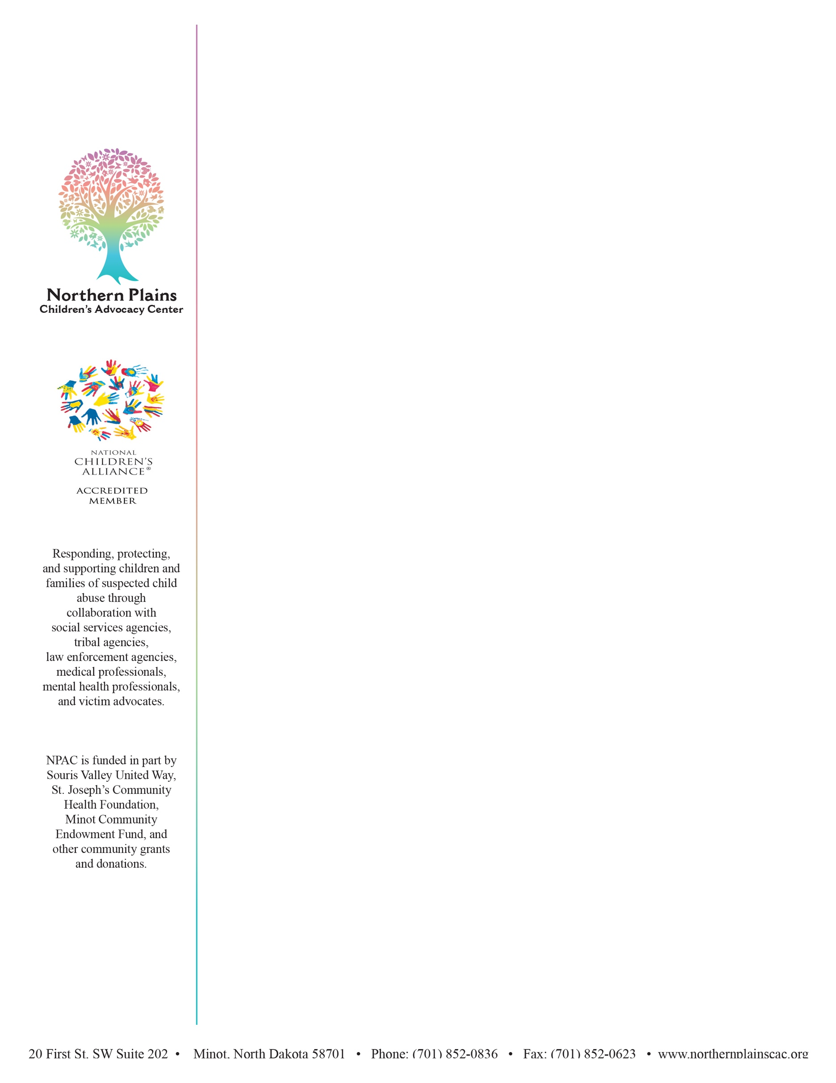
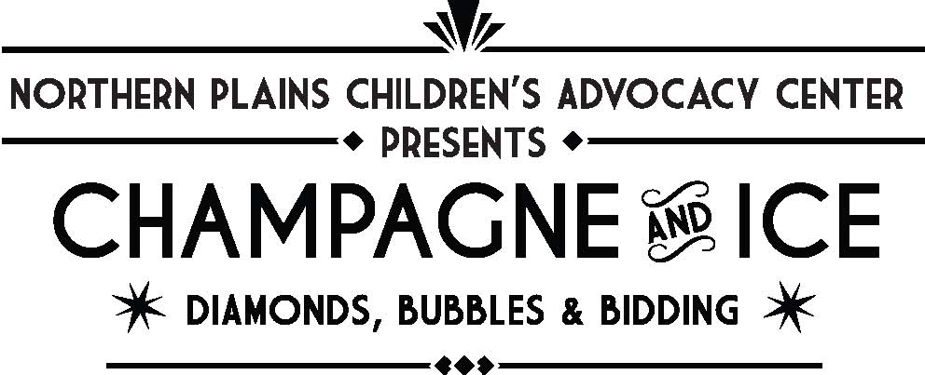

The Northern Plains Children’s Advocacy Center provides a compassionate and effective way to bring services to children victimized by sexual abuse and other crimes. NPCAC services significantly reduce the trauma associated with child sexual abuse and helps to hold offenders accountable. The NPCAC provided services for 636 children and their family members in 2023.

As a 501(c)(3) Charitable Organization, our funding comes from various grants and community donations. All services are provided free of charge to the families and children who come into the NPCAC.
We invite you to participate in our upcoming fundraising event and respectfully request a financial donation and/or other contribution that we may include in our auction. Your financial and/or auction item donation will help the NPCAC continue in serving children and families. All contributions are tax deductible.
The 2025 Champagne & Ice Gala will be held at the Clarion Hotel, 6pm, on Saturday, February 15, 2025, beginning with a social and silent/online auction. Presentations will take place before our live auction. There will be a raffle for diamonds following the live auction.
Tickets are $50, which includes admission, hors d'oeuvres, and champagne. Tickets will be available for purchase at our event site, npcac.cbo.io. Guests must be 21 or older to attend.
If you have any questions, would like a tour of the center, or would like us to speak with your group, please do not hesitate to give us a call at (701) 852-0836.
Ways you can contribute:

Sponsorship Table - $1,000.00
8 tickets for the event
Table sign
VIP Seating/Treats
Name or Business Logo in Program and Event Landing Page
Verbal & Slideshow Recognition
Champagne for Table
Table Sponsorships can only be provided with payment of the $1000.00 Sponsorship Fee and cannot be traded for any other form of donation

Sponsoring our Memorabilia or Diamond Raffle
Items to Be Announced
$500 – $5,000

Purchasing Tickets

Donation of an Auction Item or Monetary Gift
All Donations of $1,000.00 or more receive Name or Business Logo in our Program and Event Page, and Verbal & Slideshow Recognition at the Event

All Sponsors
Logo Added to Our Online Auction Website

