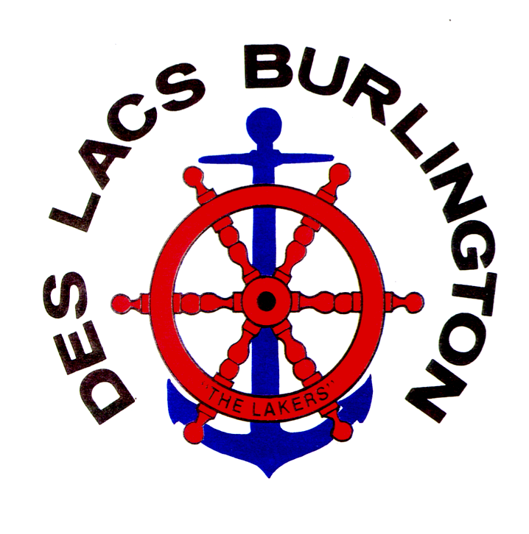
UNITED PUBLIC SCHOOL DISTRICT NO. 7
CHRISTOPHER BACHMEIER, SUPERINTENDENT DIRECTORS
Burlington-Des Lacs Elementary Brenda Buri, President
301 Wallace, Burlington, ND 58722-2235 Josh Sundsbak, Vice President
Des Lacs-Burlington High School Chad Brown, Director
PO Box 117, Des Lacs, ND 58733-0117 Jayme Burkhart, Director
725-4334 (HS) – 725-4375 (FAX) Amy Ralph, Director
839-7135 (E) – 838-1573 (FAX) Jody Askvig, Business Manager

Scott Medalen, High School Dean of Students/AD Kayla Andersen, Elementary Principal
Josh Brown, Asst. Elem & JH Principal
www.dbhs.united.k12.nd.us
__________________________________________________________________________________

April 9, 2026
To Whom It May Concern at SRT:

The Des Lacs Burlington (DLB) School Future Business Leaders of America (FBLA) chapter has had a year of success. FBLA is a high school program that prepares students for careers in business through academic competitions, leadership development, and educational programs. This year, our students competed at the State Convention that was held in Bismarck from March 29th – 31^{st.} From this competition, there were 20 students who excelled and qualified for the National Conference, which will be held in San Antonio, Texas June 27th – July 3rd, 2026. At the National Conference, students will compete at the national level and attend educational seminars that promote business leadership and organizational development, as well as develop lifelong skills and relationships with other FBLA students from across the nation.
Although this is an amazing opportunity, it does come with financial obligations. Our students have been actively fundraising throughout the school year to proactively prepare for National Conference opportunities. Our students have completed Monday Night Football Books, selling pizza/cookie dough, and a bake sale auction. They are currently preparing for a community-based Bingo/Potluck Night, a raffle, and an online auction to assist with costs of attending the National Conference.

In addition to the efforts listed above, the DLB FBLA program is asking for monetary donations from your organization to help with the final costs. These costs will be utilized for travel, lodging, conference expenses and food expenses. Costs will be evenly divided between individuals attending along with supporting the required adult supervisors/volunteers for the conference.

Thank you for your consideration of helping our students with this wonderful opportunity. Please reach out with any further questions regarding the request.

Sincerely,

Kayla Andersen, representing the DLB FBLA Chapter: 701.839.7135

