Upham Fire Protection District
GUN RAFFLE &
TEXAS HOLD’EM NIGHT
October 21st, 2023 at the Upham Fire Hall
Doors open at 5pm * Poker starts at 6pm
Lunch Served * Cash Bar
Main 75 Gun Raffle Drawing at 9pm * New Raffle Fun
Party Prize – Value $300 guarantee – Free to Enter
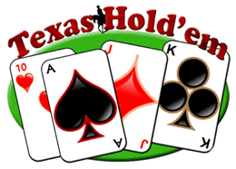
For more information contact Chet at 263-7060
All winners MUST meet State and Federal Firearms Regulations
Purchase is not a charitable donation
Guns subject to availability
****Follow UFPD Facebook page for event updates****

