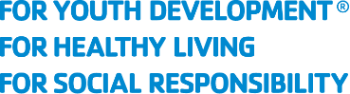
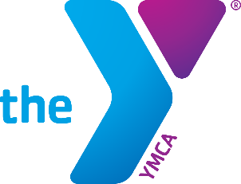

Dear Cassidy and SRT team,

I am writing to you as the Healthy Living Director of the Minot Family YMCA to invite you to be the major sponsor for our upcoming first ever annual fundraising event, “Play it Forward”. This will be the kick-off to our sustaining campaign to help support the mission of the Minot Family YMCA.

As we prepare for this family-oriented night of food and games, we are seeking financial support to help us cover the costs associated with offering it. We believe that SRT would be a great partner for us, being a strong community supporter and advocate for community health and wellness.

By sponsoring our event, you will have the opportunity to showcase your support for nurturing family health to a wide audience. We plan to promote your business through our social media channels, promotional materials throughout the community and throughout the evening of the event. We are also open to discussing other ways in which we can promote SRT.

A few things we already have planned for the evening to be hosted at the Sleep Inn are a plated dinner, silent auctions, a variety of gaming tables including games such as Plinko, Wall of Money with a reveal of a major project (We discussed placing the SRT logo on the face of this), a digital 50/50, a wine/soda pull, a wheel of fortune wheel, deck of card raffle and more, with the major event of the night being bingo. We are currently seeking a local personality to MC the event and to call bingo.

We believe that this partnership would be mutually beneficial, and we are committed to working with you to ensure that your investment in our event is worthwhile.

Thank you for considering our request for sponsorship. We are excited about the opportunity to partner with SRT and continue to promote family health and well-being.

Sincerely,

Russell Gust, MS, ASCM-CET
Healthy Living Director
Minot Family YMCA

