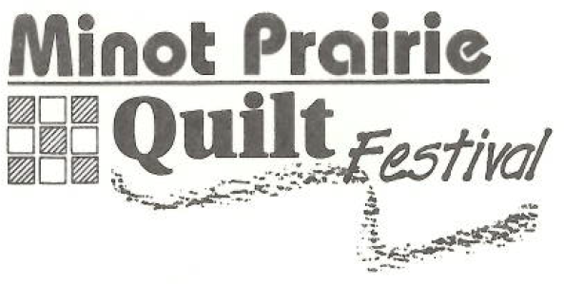

January 2025
Greetings,

The Minot Prairie Quilt Guild is a 501(c)(3) nonprofit organization devoted to promoting social and educational quilting pursuits, sponsoring and cultivating interest in the appreciation and preservation of needle arts, and promoting fellowship and exchange of ideas. Towards this purpose, we’re preparing for our 30th annual Quilt Festival.

The Minot Prairie Quilt Festival, “Remembering Our Past, Shaping Our Future” will be April 4-5, 2025 at the North Dakota State Fair Center Minot, North Dakota. The Festival features NACQJ judge, Diane Pitchford.

At our last event, approximately 1,500 people viewed our Quilt Show and shopped at our vendor booths. The Minot Prairie Quilt Festival is the largest annual Festival in North Dakota. Attendees come from all over the U.S. and two provinces in Canada.

As a way of increasing attendance and raising funds for our community service projects we have what we like to call the Basket Bonanza. During the festival the baskets are on display for all visitors to see and buy tickets to win the baskets. We are only able to do this through the generosity of donors like you. Sponsors will be recognized through signage on each of the baskets as well as signs displayed through the Quilt show arena.

Additionally, we welcome any promotional materials such as fliers, brochures, etc. that can be displayed near the basket to further promote your business.

We thank you in anticipation of your generous support and for believing in us and our mission. Together, we can make the quilting community better. If you have any questions about our organization or our work, please feel free to visit our website at www.minotquilters.com. Thank you for your consideration. I look forward to hearing from you!

Sincerely, Please mail donations to:
Carolyn Rousey
420 16th Street NW
Minot, ND. 58703
Carolyn Rousey
carolynrousey@yahoo.com

