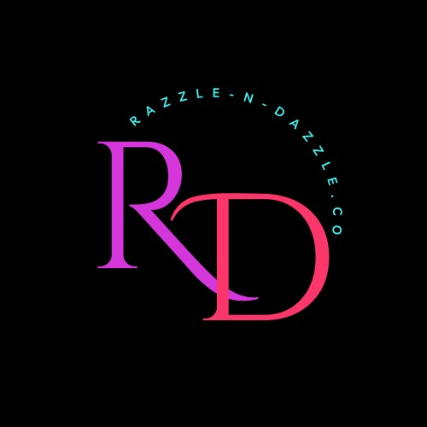
Razzle-N-Dazzle Spreading Sparkles…Parkinson’s & Mental Health Awareness

Dear

My name is Holly Jacobs, but you can call me Dazzle! I am writing to you on behalf of my charity Razzle-N-Dazzle.Co and (W)Evolve Mental Health Services Non-profit. We are collaborating to bring Parkinson’s and mental health awareness to our community in the form of art therapy and out of the box thinking.
My first year I organized a Blingo (Bling + bingo = Blingo) event by myself supporting Parkinsons awareness and raised $3000. Last year, I created a fabulous team of collaborators and with a little luck and whole lot of blind faith and donors like you, we were able to donate almost $9000..This year, once again we are relying on luck a lot of faith and especially our donors to reach our largest goal yet, at $15,000! Our charity gala is on April 14th, 2024, at The Baggage Claim 15 North Main Downtown Minot. We have fun activities planned for this event, with a Paris theme incorporated and BLINGO! This event is a vital source of funding that allows us to fulfill our mission. Once again, we will be supporting our partner (W)Evolve Mental Health Services Non-Profit sector. I am excited to announce our second recipient will be another wonderful art collaboration! I am partnering up with Deb from Natures Nook Children’s Toys and Books. We will be traveling to assisted living homes and teaching paint/art classes! I know right, I am so excited about this partnership!
One of the highlights of our event is an Art auction, and we are reaching out to generous businesses like yours to see if you might be interested in a sponsorship, donating an exciting item or experience We are also incorporating sustainability into this year’s event as much as we can. Most importantly, you will have the satisfaction of supporting a cause that is making a real difference in our community.
We understand your time is valuable. To learn more about our organization and discuss this event, please do not hesitate to contact me at 850-758-7006. Email me with any questions. I will be happy to answer any questions you may have. Please contact me by Jan 2024 to confirm your sponsorship/auction item donation, or a piece of art to donate.
Thank you for your time and consideration. We look forward to partnering with you to make a positive impact.
Sincerely,
Sparkle-Up
Holly (Dazzle)Jacobs
Razzle-N-Dazzle.Co Spreading Sparkles…Parkinson’s & Mental Health Awareness
It SPARKLES the brightest in the darkest of corners.

Fun Fact- 20% of people with Parkinsons never had the opportunity to experience creativity prior to having Parkinson’s! Suddenly…they have become artistic and creative!
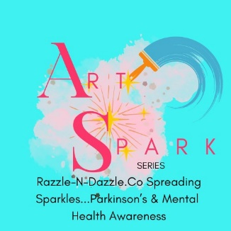
Introducing the Art Spark Series

